**React Native Check TextInput is Empty or Not**

This is an example of React Native Check TextInput is Empty or Not. As the topic name describes itself, we will check the TextInput on a click of the Button. This is very useful if you are making any form that has some mandatory fields.

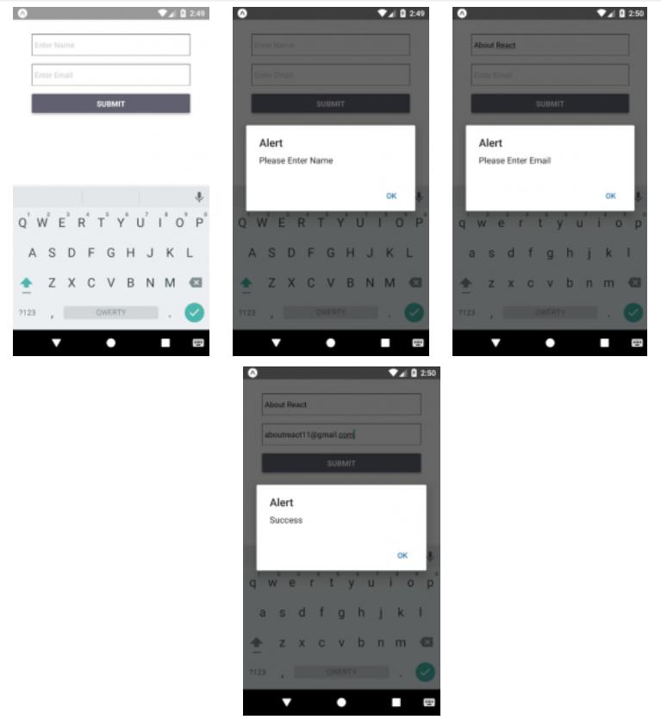

/*This is an example of React Native Check TextInput is Empty or Not*/

import React, { Component } from 'react';

import {

AppRegistry,

StyleSheet,

TextInput,

View,

Alert,

Button,

} from 'react-native';

export default class App extends Component {

constructor(props) {

super(props);

this.state = {

TextInputName: '',

TextInputEmail: '',

};

}

CheckTextInput = () => {

//Handler for the Submit onPress

if (this.state.TextInputName != '') {

//Check for the Name TextInput

if (this.state.TextInputEmail != '') {

//Check for the Email TextInput

alert('Success')

} else {

alert('Please Enter Email');

}

} else {

alert('Please Enter Name');

}

};

render() {

return (

<View style={styles.MainContainer}>

<TextInput

placeholder="Enter Name"

onChangeText={TextInputName => this.setState({ TextInputName })}

underlineColorAndroid="transparent"

style={styles.TextInput}

/>

<TextInput

placeholder="Enter Email"

onChangeText={TextInputEmail => this.setState({ TextInputEmail })}

underlineColorAndroid="transparent"

style={styles.TextInput}

/>

<View style={{ marginTop: 15 }}>

<Button

title="Submit"

onPress={this.CheckTextInput}

color="#606070"

/>

</View>

</View>

);

}

}

const styles = StyleSheet.create({

MainContainer: {

flex: 1,

margin: 35,

},

TextInput: {

width: '100%',

height: 40,

paddingLeft: 5,

borderWidth: 1,

marginTop: 15,

borderColor: '#606070',

},

});